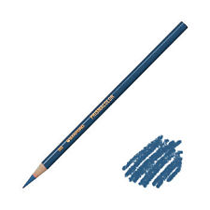
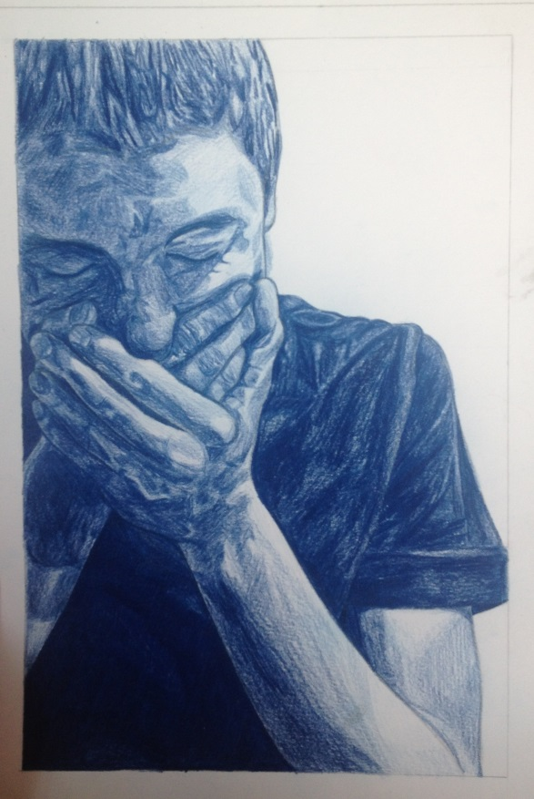
This is the only pencil I used to shade this project. I started out with pencil to draw it, and then used the dark blue colored pencil.

