**Shopping in the Catskills**

**Although there are not many malls in the Catskills, there are plenty of unique boutiques and antique stores located throughout the main towns.**

**Check out the shopping districts in these towns!**

**Saugerties**

**Catskill**

**Windham**

**Hunter**

**Kingston**

**Tannersville**

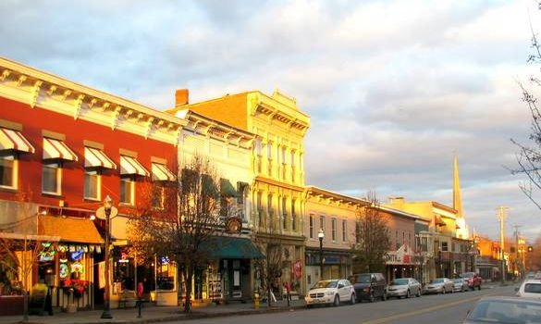

**Main Street, Saugerties, NY**