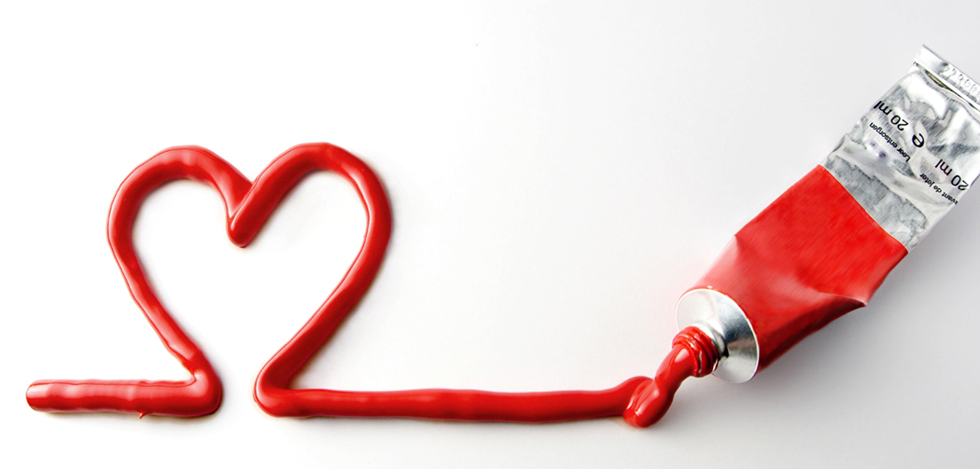

Love Quotes

* “You know you're in love when you can't fall asleep because reality is finally better than your dreams.”   
  ― [Dr. Seuss](http://www.goodreads.com/author/show/61105.Dr_Seuss)
* “Love is that condition in which the happiness of another person is essential to your own.”   
  ― [Robert A. Heinlein](http://www.goodreads.com/author/show/205.Robert_A_Heinlein), [*Stranger in a Strange Land*](http://www.goodreads.com/work/quotes/908211)
* “Being deeply loved by someone gives you strength, while loving someone deeply gives you courage.”
* “Love looks not with the eyes, but with the mind.”   
  ― [William Shakespeare](http://www.goodreads.com/author/show/947.William_Shakespeare), [*A Midsummer Night's Dream*](http://www.goodreads.com/work/quotes/894834)
* “The real lover is the man who can thrill you by kissing your forehead or smiling into your eyes or just staring into space.”   
  ― [Marilyn Monroe](http://www.goodreads.com/author/show/82952.Marilyn_Monroe)