Requirements Document Creation:
- First elicit the user requirements
  - Interview – Ask what they want in the system
  - Scenario – Ask how they do one task in a normal day
  - Use Case – Draw one use case
  - Ethnography – we will skip – but be sure you know how that would be done. Why are we skipping it?
- Write user requirements- Number them
  - Natural Language
    - Be careful that every word means what you want it to. Be sure it is complete. (When you write the system requirement from it, you will know better what is meant by this.)
    - Use language everyone, not just a techie, can read
    - Be sure not to go too deep, crossing into the system requirements level.
  - Structured Language
    - Name of Function (you choose a name that communicates well)
    - General description (a sentence or two about what the function is)
    - inputs (Describe inputs and where they come from)
    - source of the inputs if applicable
    - outputs (Description of outputs and where they go to.)
    - Action ( Description of the action to be taken and all logic involved)
    - Pre conditions (if any)
    - Post conditions (if any)
    - The side effects (if any) of the function.
  - Tabular to supplement
    - Find a requirement that lends itself to a table. One that yields a choice of actions for the system is good.
    - make a 2 column table of the condition and action
- Write system requirements for a few of the user requirements
  - Number these with a different numbering system than the user requirements
  - At the end of each system requirement, write the number of the user requirement (s) that is fulfilled by it.

Elicitation Method 1: Interview
Question list
1
2
3

Issues to explore
1
2
3
Results:

Elicitation Method #2: Scenario
Initial assumption:
Normal Process:
What can go wrong:
Other activities:
System state on completion:

Elicitation Method #3 - Draw Use Cases
Who is involved in this system?
What other systems are involved?
What do each of the actors do?
Draw a few use case diagrams

Elicitation Method #4 - Ethnography
Walk with a user through a typical day. Make notes about workflows you identify.
Make sure you consider all of these types of requirements:
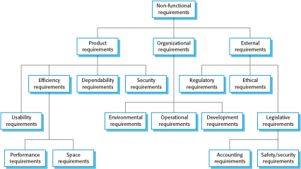
Now produce the user and system specs:
One example:
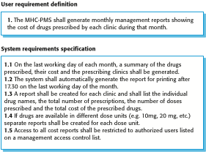
Write a requirement in one of each of the three following ways:

Natural Language Requirement:
  - Invent a standard format and use it for all requirements.
  - Use language in a consistent way. Use shall for mandatory requirements, should for desirable requirements.
  - Use text highlighting to identify key parts of the requirement.
  - Avoid the use of computer jargon.
  - Include an explanation (rationale) of why a requirement is necessary.
EX:
3.2 The system shall measure the blood sugar and deliver insulin, if required, every 10 minutes. (Changes in blood sugar are relatively slow so more frequent measurement is unnecessary; less frequent measurement could lead to unnecessarily high sugar levels.)
3.6 The system shall run a self-test routine every minute with the conditions to be tested and the associated actions defined in Table 1. (A self-test routine can discover hardware and software problems and alert the user to the fact the normal operation may be impossible.)
Structured Language Requirement:
Requirement name and number:
Function
Description:
Inputs
Source
Outputs
Action
Special Requirements
Pre-condition
Post-condition
Side effects

Tabular Specification to supplement a requirement
Condition | Action

