Recursion Outline:
Recursive in English is a procedure that can repeat a version of itself indefinitely – such as mirrors looking at each other.
Recursion in Mathematics is: defining an object in terms of itself:
Recursion in Java is a method that calls itself (or calls something that then calls itself) repeatedly. In order not to repeat forever, it needs to have a stopping point.
Factorials:
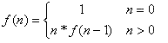
Fibonacci:
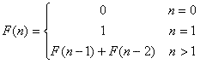
Snowflakes:
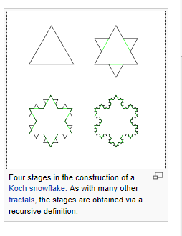 (http://en.wikipedia.org/wiki/Recursive_definition)
A really good explanation is found at: Amjad, Zeeshan. "Recursion Primer Using C : Part 1." - CodeProjectÂ®. The Code Project, 22 Apr. 2008. Web. 19 Mar. 2012. <http://www.codeproject.com/Articles/25470/Recursion-Primer-Using-C-Part-1>.
Excerpts of Amjad’s article follow:
How does Recursion work?
Linear Recursion: Factorials:
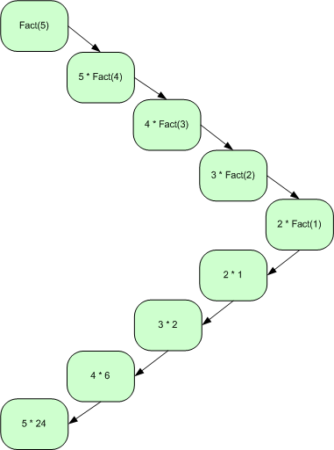

int Factorial(int no)
{
// error condition
if (no < 0)
return -1;

// termination condition
if (0 == no)
return 1;

// linear recursive call
return no * Factorial(no - 1);
}
Fibonacci: Binary Recursion:
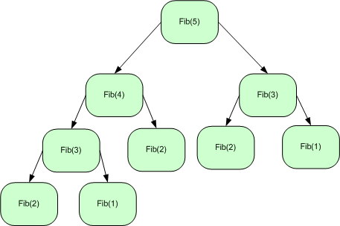

int Fib(int no)
{
// error condition
if (no < 1)
return -1;

// termination condition
if (1 == no || 2 == no)
return 1;

// binary recursive call
return Fib(no - 1) + Fib(no - 2);
}
Now, for a great non-number example, on to codingbat : http://codingbat.com/java/Recursion-1
countPairs:
We'll say that a "pair" in a string is two instances of a char separated by a char. So "AxA" the A's make a pair. Pair's can overlap, so "AxAxA" contains 3 pairs -- 2 for A and 1 for x. Recursively compute the number of pairs in the given string.
countPairs("axa") → 1
countPairs("axax") → 2
countPairs("axbx") → 1
Definition:
When there are less than 3 letters :the answer is that there are 0 pairs
When there are more than 2 letters :
When the first and third letter match, the answer is 1 pair + all the pairs found in the string that starts with the second letter.
When the first and third letter match, the answer is just all the pairs found in the string that starts with the second letter.
Thinking about the header
- What does this method need to know? -→ the letters being examined
- What does this method need to return? → the number of pairs
- So what is the header: public int countPairs(String str)
How to code When there less than 3 letters :the answer is that there are 0 pairs
- Use an If statement
- Determine if the length is 2 using str.length()
How to code When there are more than 2 letters :
- Get the first letter using str.charAt(0)
- Get the third letter using str.charAt(1)
- Get the string that starts with the second letter using str.substring(1)

