The Human Ancestry:
The Evolution of Homo sapien sapien

Human's have been evolving for millions of years. Our skeltal structure and characteristics have changed. We evolved out of a common ancestor, that is shared with other primates. In our history, we have evolved from a quadropead to a bipead. Our diet has changed, and our intelligence has increased. We began spreading all over the world, and have formed great technologies, begining with stone tools. Our species has become creative and appresative. On the filp side we have always been competative, and in some cases have become violent and self-centered. Our human ancestors diverged out of one another, and it is suspected that in some case we interbread. Evolution takes place through Darwinian thoery, survival of the fittest and in gradual and punctual speeds. The modern Homo sapien is still evolving.
For more information on evolution and our Human ancestry, there are many books and web sites dedicated to informing the public on the truth of our past.

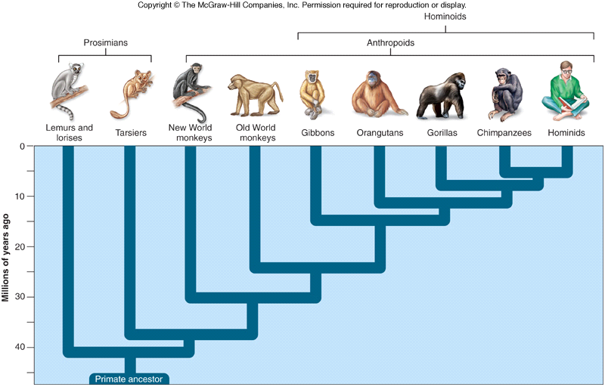
Here are some diagrams to give you a breif overview of our ancestry line:
