Massapequa Fire Department

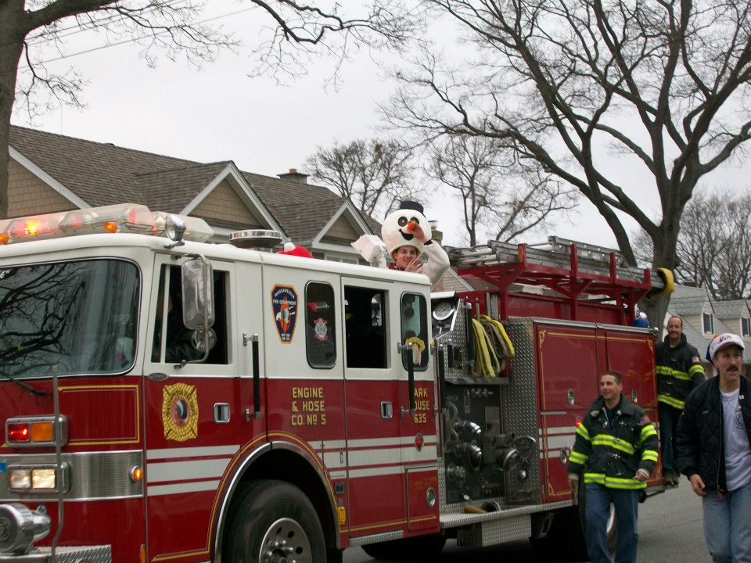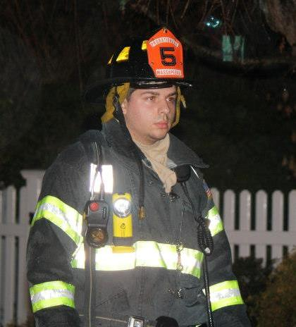

House fire on Sunset Blvd Christmas “Santa Run”

Massapequa, NY Massapequa Park, NY

December 2012 December 2012

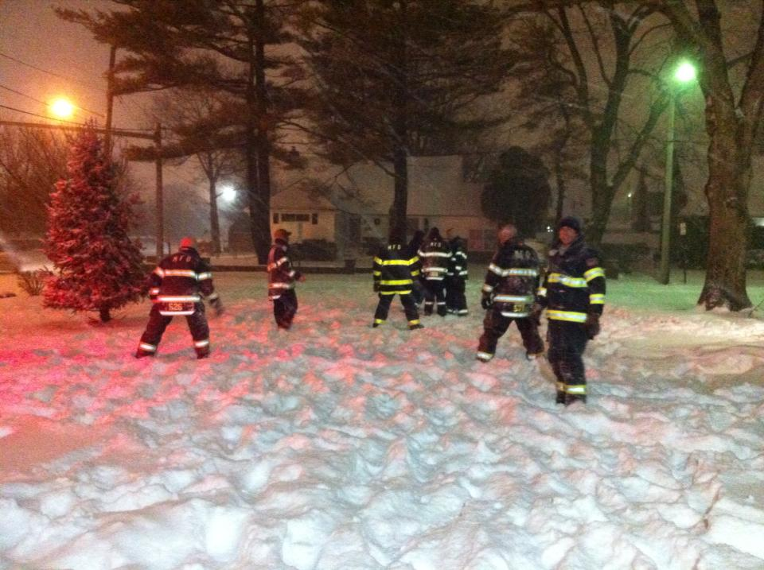

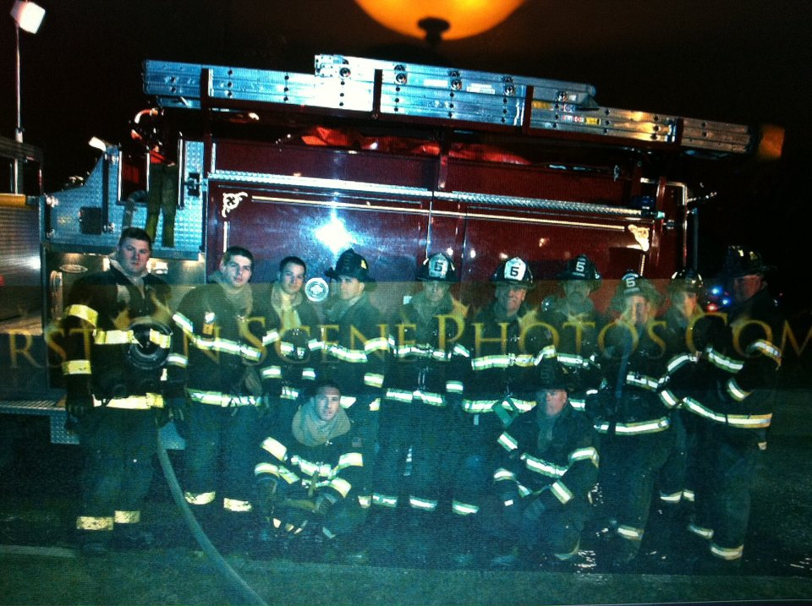

Massapequa FD House fire on Van Buren St

Snow Stand-By Massapequa Park, NY

Massapequa, NY February 2013

February 2013