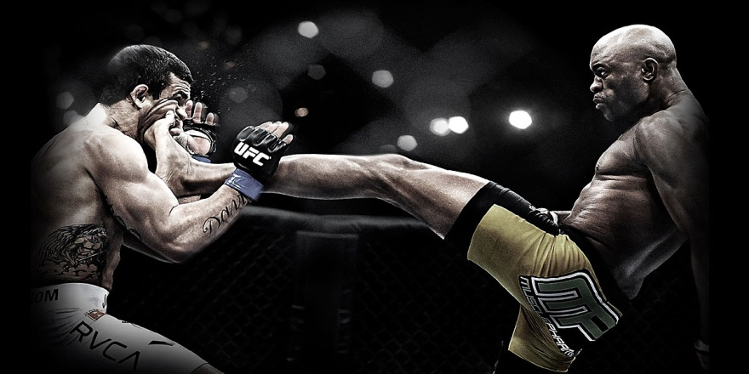

Our Website is made for promoting and updating UFC fans on upcoming fights. We let the fans know when the fight is, where the fight is, and also our predictions on the fight. Our contact information lets our visitors give us their opinions on whether or not they believe certain fighters will win or lose in the upcoming events. Our website will keep you posted as frequently as we can so any question hit our "contact us" page and ask away!

