Osamu Tezuka: “The Godfather of Anime/Manga”

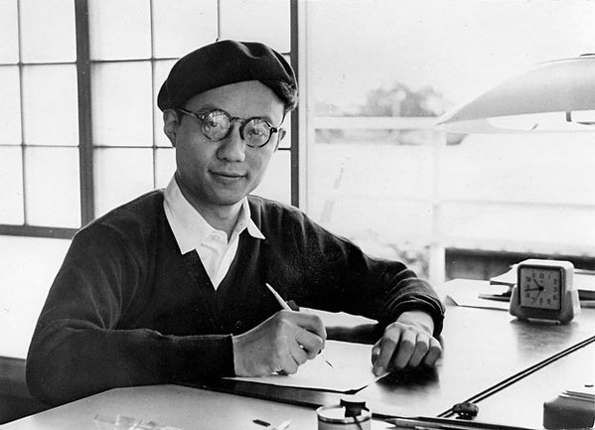

http://tezukainenglish.com/bm/about/tezuka-life/osamu-tezukas-life-story-1958---1964.shtml

