Nina!  She has been one of my best friends since we were little! | 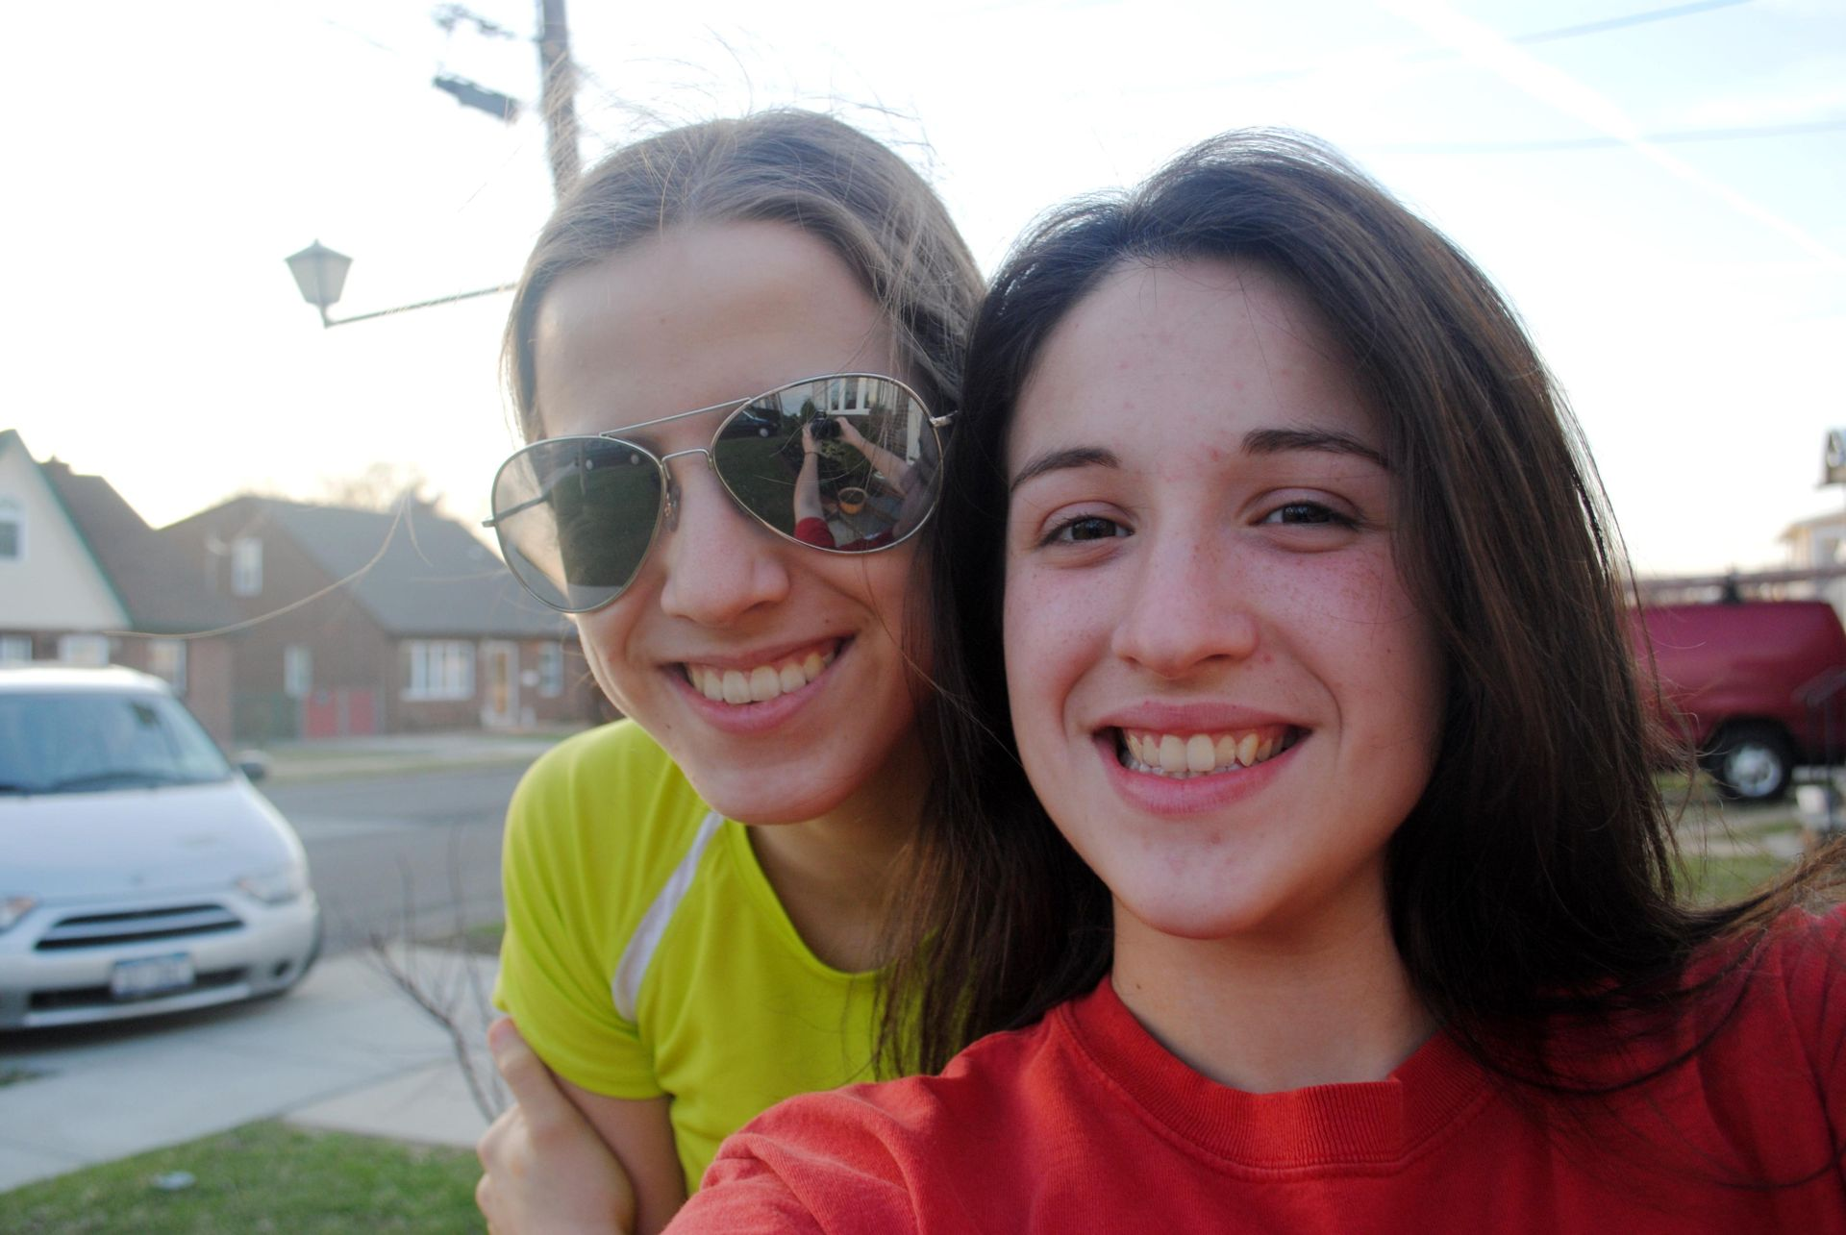
Vanessa!  She is my older sister! Some people think we are twins! | 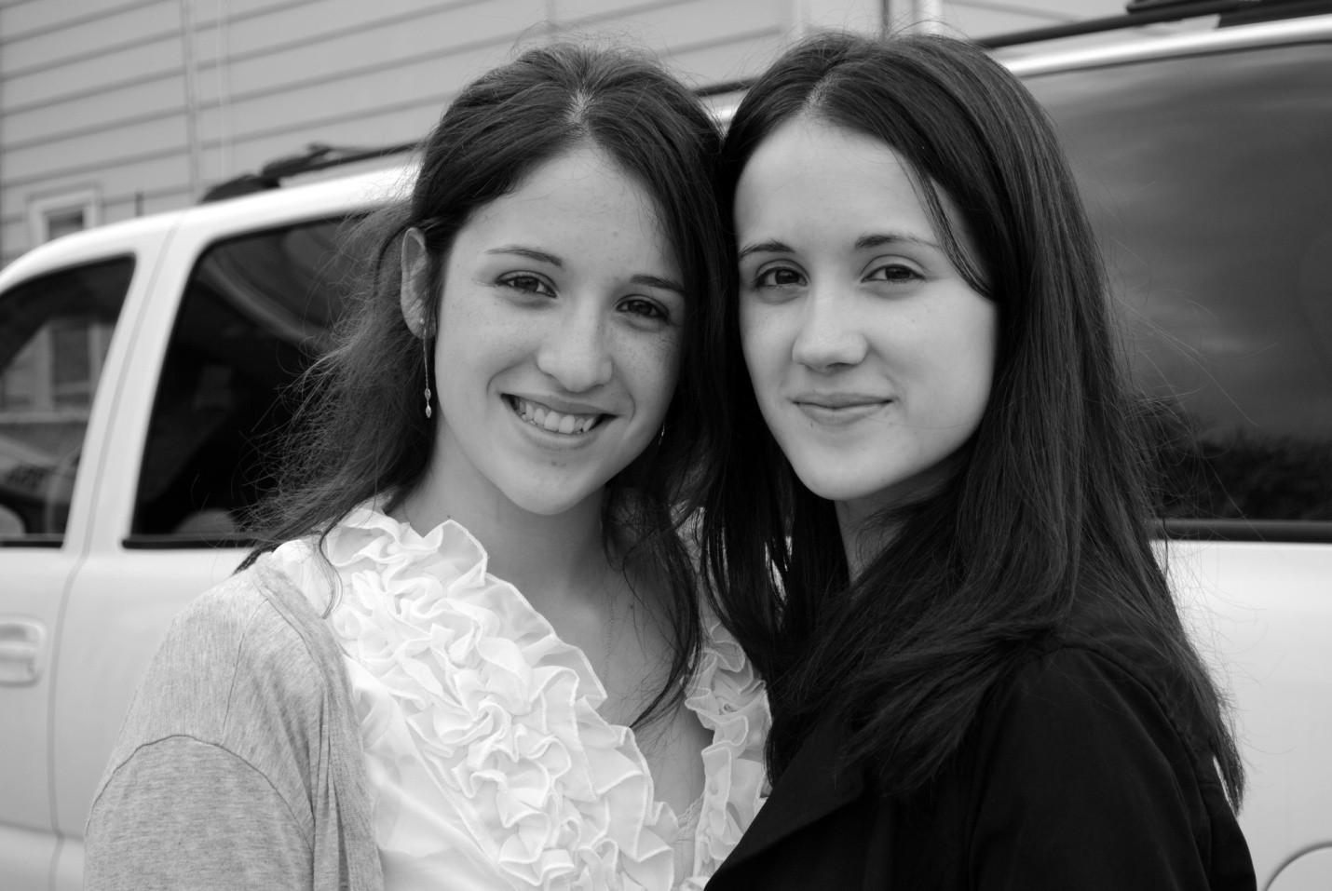
Helder!  He is Vanessa’s boyfriend and is like a brother to me! | 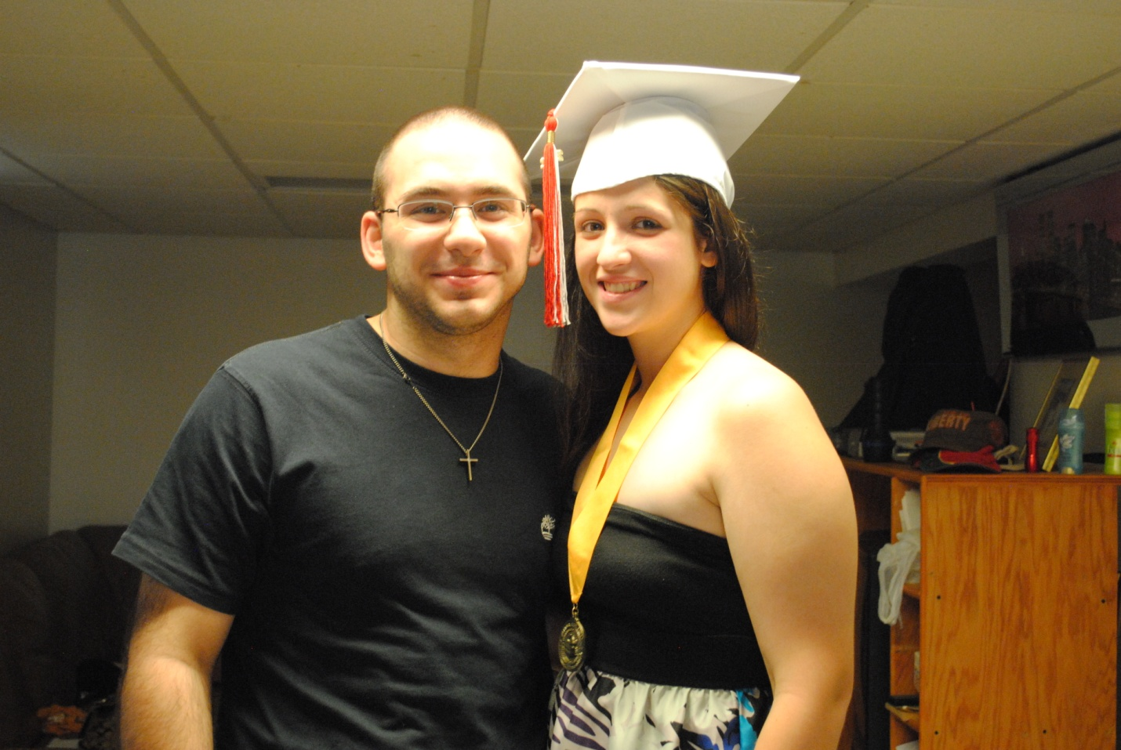
Michelle!  She is my second oldest sister! We share a room together and we are really crazy together! | 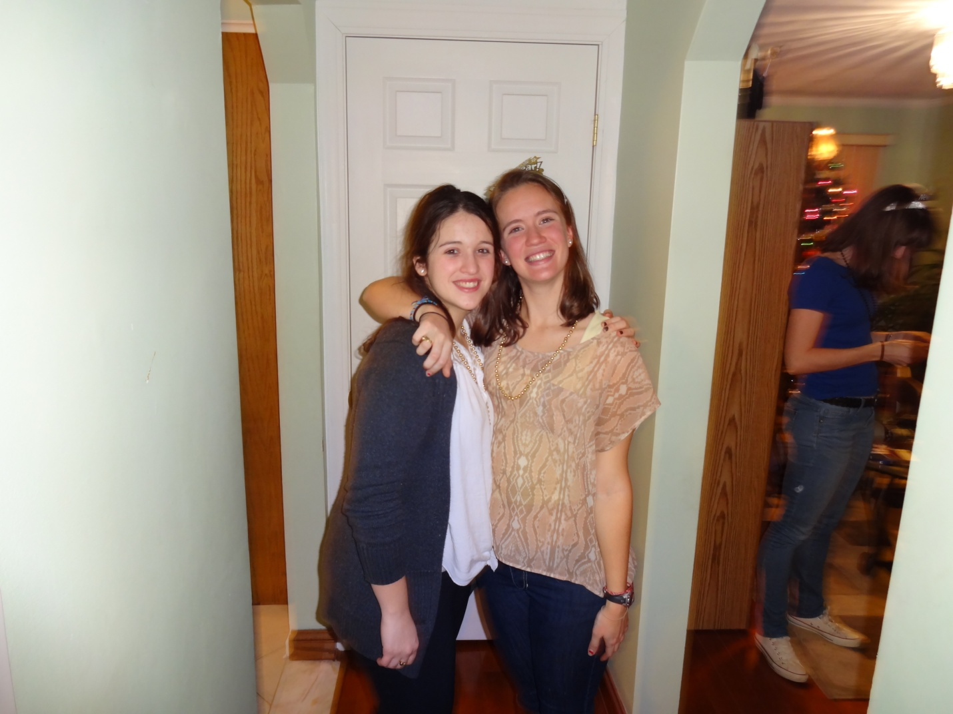
Joe!  He is my little brother! Although he can be a pain sometimes, I still love him! | 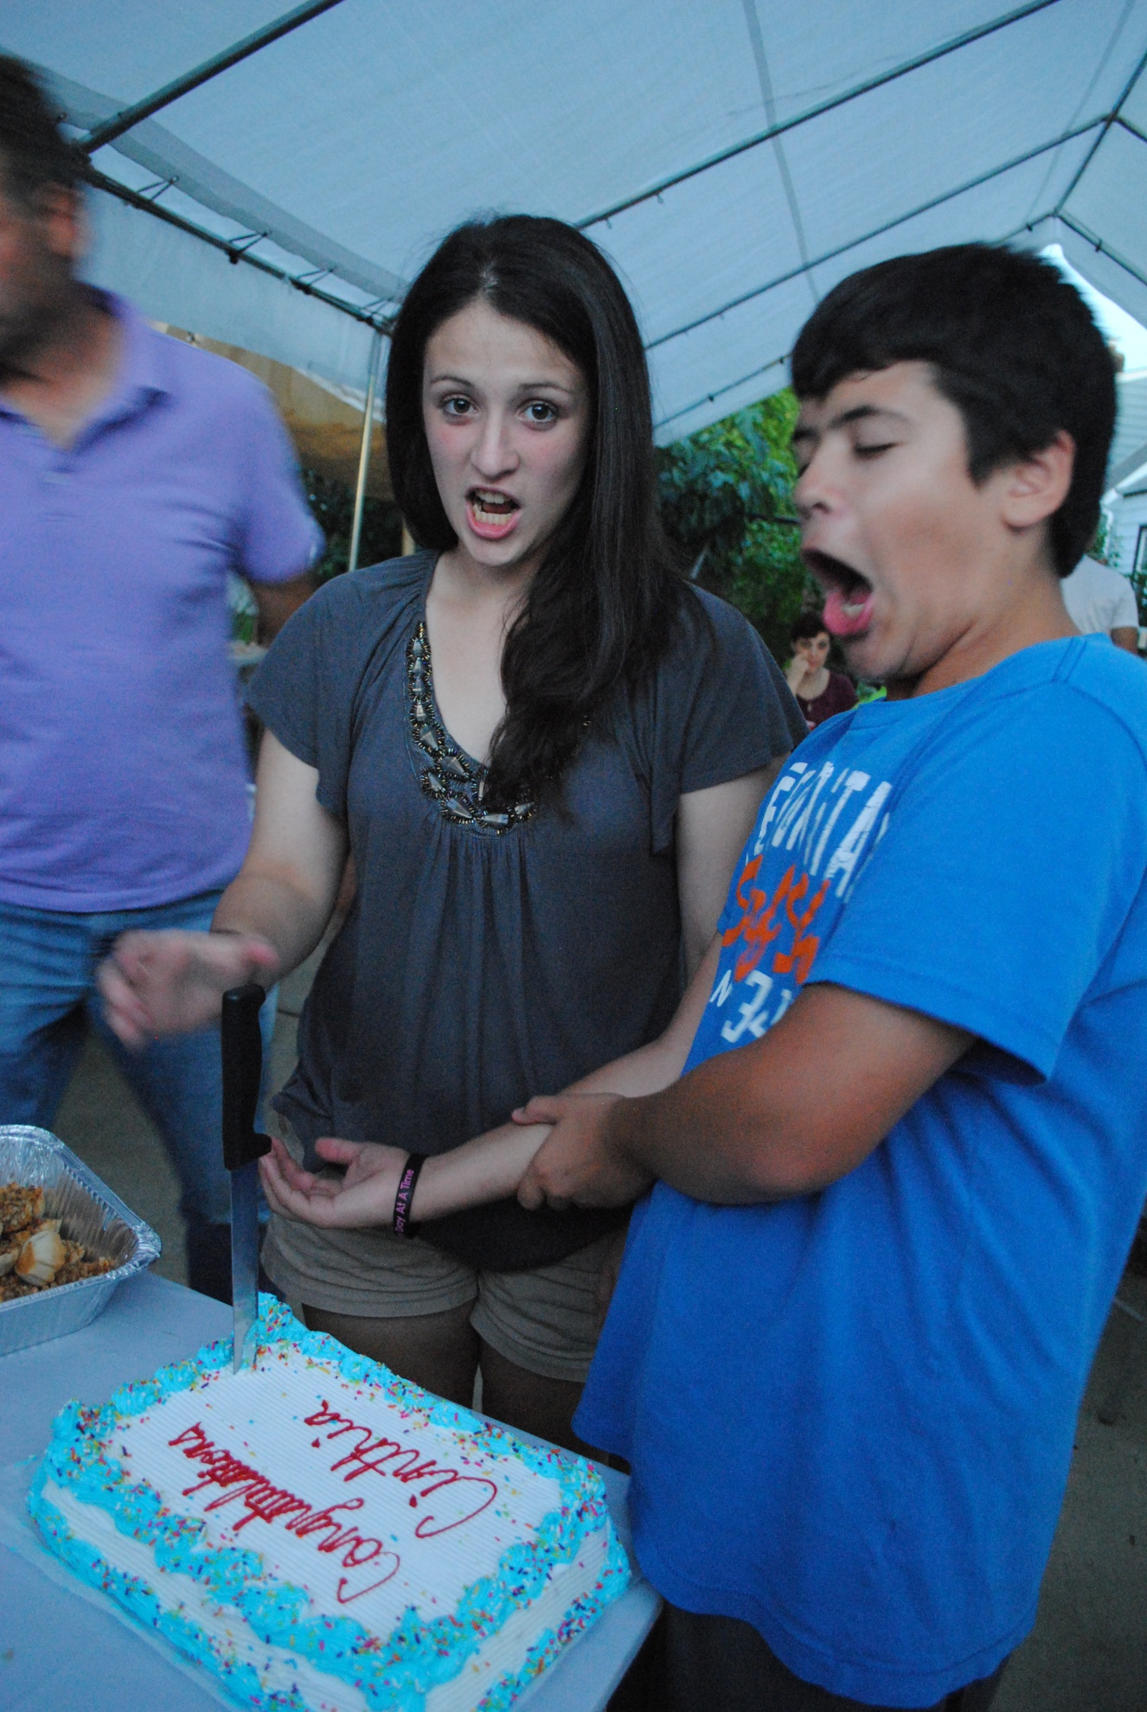
Matt!  He is my boyfriend and my best friend! I can be myself around him and I love that about him! | 