Quotes About Love and Marriage

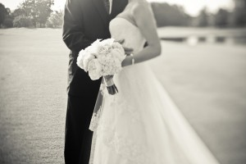

“Marriage: Love is the reason. Lifelong friendship is the gift. Kindness is the cause. Til’ death do us part is the length.” -Fawn Weaver

“A successful marriage requires falling in love many times, always with the same person.”-Mignon McLaughlin

“Marriage is a mosaic you build with your spouse. Millions of tiny moments that create your love story.”-Jennifer Smith

“The greatest marriages are built on teamwork. A mutual respect, a healthy dose of admiration, and a never-ending portion of love and grace.”-Fawn Weaver

[Happy is the man who finds a true friend, and far happier is he who finds that true friend in his wife.](http://www.brainyquote.com/quotes/quotes/f/franzschub325151.html) -[Franz Schubert](http://www.brainyquote.com/quotes/authors/f/franz_schubert.html)

You know you're in love when you can't fall asleep because reality is finally better than your dreams. -Dr. Seuss