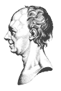
The Euler Society Newsletter

Volume 2, number 2  June, 2003 | Visit The Euler Society home page at http://www.eulersociety.org.

Euler 2003 Program finalized
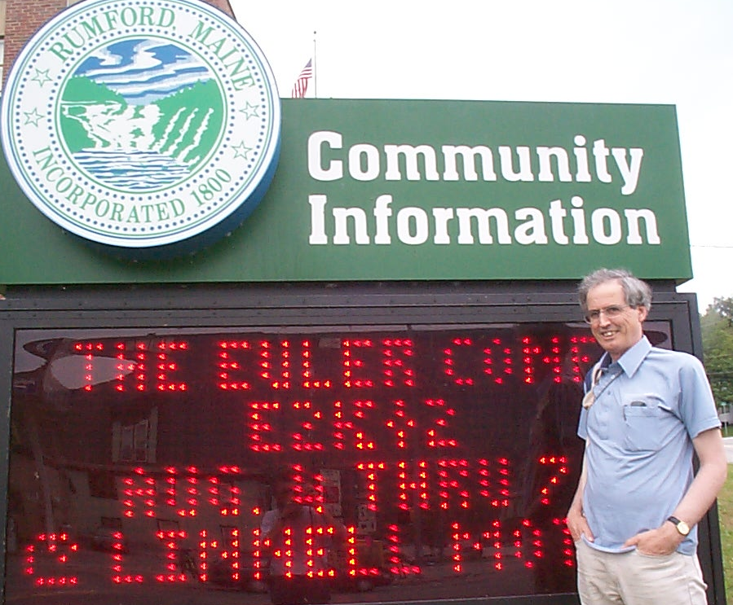
The program for Euler 2003, the second annual meeting of The Euler Society is ready. The meeting will be held August 10 to 13, 2003 at the Conference Center of Roger Williams University in Bristol, Rhode Island. It will begin the evening of Sunday, August 10 with registration and a reception. Fourteen talks and two workshops will keep attendees occupied through noon on Wednesday, August 13. An outline of the Program appears at the end of this Newsletter.
People planning to attend should register and make reservations as soon as possible. Instructions on how to do that are in the Announcement at the end of the Newsletter, but before the Program. Contact John Glaus if you still have questions on how to register. He’s good at that; that’s why we made him Ombudsman.

Photos from Euler 2002

Several pictures from last year’s meeting of The Euler Society appear in this newsletter. Because there are technical problems keeping captions attached to their photos when eMailing these documents, we’ll put all the captions here in the text.
The first photo is Oxford Don Raymond Flood at the Community Information sign welcoming the Conference to Rumford, Maine.
Farther down is the group photo of all the attendees we could round up, standing outside the Conference Center. How good is your eyesight? How good is the resolution on your computer monitor? How many of the people can you identify?
Later there is a shot of Fred Rickey and Eisso Atsema in the foreground, Dominic Klyve and a tiny piece of David Pengelley in the background, at the French language original sources workshop. Rob Bradley will be conducting a similar workshop at Euler 2003. There will also be an original sources workshop in Latin. We’ll provide handouts.

The König Affair On Line at St. Andrews

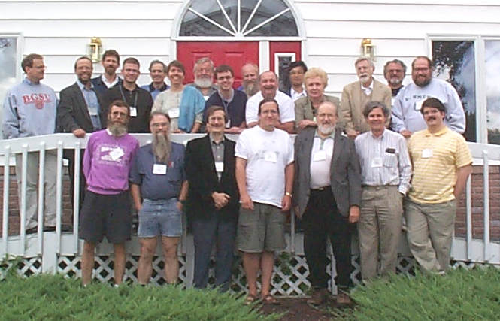 Readers who have studied the lives of Voltaire or Maupertuis may have come across an incident called the König Affair. In a nutshell, Maupertuis claimed precedence for a discovery called the Principle of Least Action. Many people think that Euler’s claim to the Principle was stronger, but Euler himself ceded precedence to Maupertuis. König, though, thought that Leibniz deserved credit, and he produced copies of letters to justify his claim. In the 253rd meeting of the Berlin Academy, in April, 1752 and under the supervision of the Maupertuis, the President of the Academy, König’s letters were judged to be forgeries, and König was humiliated. Part of the evidence against König was Euler’s essay “Exposé concernant l’examen de la lettre de Mr. de Leibnitz, alleguée par M. le prof. Koenig, dans le mois de mars, 1751. des Actes de Leipzic, à l’occasion du principe de la moindre action.” This essay bears Enestrom number 176 and is reprinted in Series II Volume 5 of the Opera Omnia.
There are several accounts of the König Affair in the literature, especially in biographies of Voltaire and of Maupertuis. A modern version is in The Man Who Flattened the Earth, Mary Terrall’s recent biography of Maupertuis. (See below.) Just recently, the St. Andrews math history web site at http://www-gap.dcs.st-and.ac.uk/history/ added an account of the König Affair. Their account dwells on the issue of forgery, and parallels another historical tale of 19th Century mathematical forgery. The URL of their version of the König affair is http://www-gap.dcs.st-and.ac.uk/history/HistTopics/Forgery_2.html.

At the Bookstore

We mentioned Mary Terrall’s new biography of Maupertuis, The Man Who Flattened the Earth: Maupertuis and the Sciences in the Enlightenment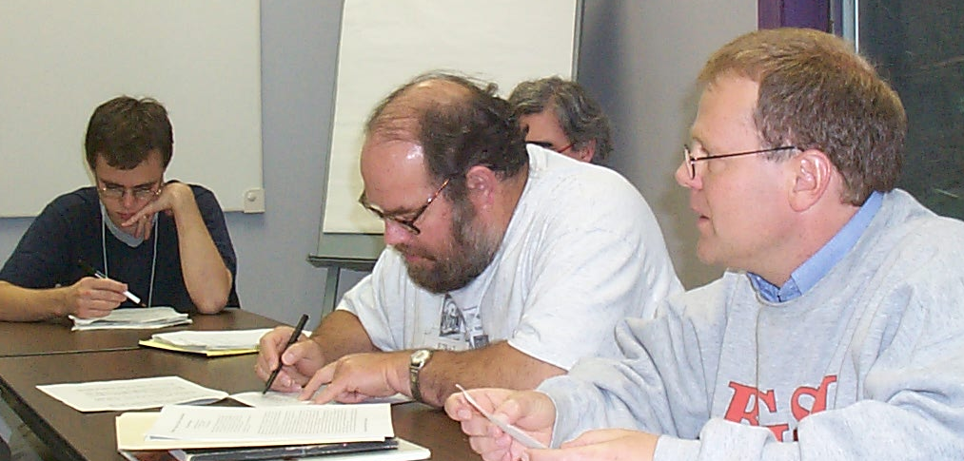 above. Maupertuis is remembered for two scientific accomplishments, the Principle of Least Action and leading the French expedition to Lapland that helped determine that the Earth is shaped like a slightly flattened sphere, longer around the equator than around the axes. It is this second achievement that gave this book its title.
Besides this, Maupertuis was President of the Berlin Academy for most of Euler’s years in Berlin. As such, Euler makes more than two dozen appearances in Terrall’s pages. The contrasts between the Maupertuis and Euler were remarkable. Euler was the son of a clergyman. Maupertuis was the son of a pirate who had been elevated to the aristocracy because of his successful adventures against English merchant ships. That is just the beginning of their differences. The two were not friends, yet they managed to be cordial and they got along quite well.
This book was published by the University of Chicago Press. It seems to me that Chicago Press books on the history of mathematics and science dwell more on culture, politics and personality than their main rivals in the subject, Princeton University Press. Contrast this book, for example, with Julian Havil’s Gamma, reviewed in the last issue of The Euler Society Newsletter, or with any of Eli Maor’s books. Such variety is wonderful
The Man Who Flattened the Earth: Maupertuis and the Sciences in the Enlightenment by Mary Terrall, University of Chicago Press, Chicago and London, 2002. ISBN 0-226-79260-5.

At the Meetings

Euler has been a popular subject at recent meetings of the various societies and associations. The Halifax meeting of the Canadian Society for the History and Philosophy of Mathematics got so many abstracts on Euler that they organized a special session to keep them all together. The same thing happened at the NYU meeting of the AMS. We list below some titles and presenters related to Euler from recent, and not so recent meetings.

CSHPM – Dalhousie University, Halifax, Nova Scotia, May 30 – June 1, 2004.
Ed Sandifer: Euler Rows the Boat
Israel Kleiner: Aspects of Euler’s Number-Theoretic Work
Robert Bradley: The Curious Case of the Bird’s Beak
John Glaus: Euler and His Friends
Christopher Baltus: The Bernoulli-Euler Proof of the Fundamental Theorem of Algebra

AMS – New York University, New York, April 12-13, 2003
Ron Calinger: Euler’s Golden Decade – 1746-1756
Rob Bradley: Euler’s All Purpose Counterexample
Chris Baltus: D’Alembert’s Solution to the Fundamental Theorem of Algebra
Ed Sandifer: Eulet’s Solution of the Basel Problem – The Longer Story

MAA/AMS – Baltimore, MD, January 15-18, 2003
Thomas J. Osler: Finding zeta(2p) from a product of sines
Ivor Grattan-Guiness: History or heritage? Historians and mathematicians on the history of mathematics
Rob Bradley: Reducing Imaginary Quantities: An Episode from the History of the Fundamental Theorem of Algebra

AMS – Northeastern University, Boston, October 5-6, 2002
Rob Bradley: The Nodding Sphere and the Birds Beak – A Vignette from the Euler-d’Alembert Correspondence
John Glaus: The Scientific Imperative in the Berlin Academy
Dick Jardine: Taylor’s Theorem – A Link Between Continuous and Discrete
Ed Sandifer: Some Connections in Euler’s Early Mathematics

New Information on Euler and Chess

A few months ago we asked our colleagues on a Chess History web site at www.chess-poster.com about Euler and chess. In particular, we asked
1. Do any of Euler’s games survive?
2. Who was Euler’s chess teacher in Berlin?
3. Who was Euler’s guest the evening “I found myself one day in a company where, on the occasion of a game of chess, someone posed this question …” as he describes at the beginning of his paper on the Knight’s Tour, E-309.
We got answers from Peru, reproduced below:

Cajamarca, Perú 2003

Estaba observando los correos de algunas personas,
pero había uno que me interesa mucho. Fue del Sr. Ed Sandifer,
había tres preguntas de la historia de Euler.
Investigué y tengo las respuestas.

1.- No existen partidas grabadas porque nadie las anotó.
2.- El maestro fué un Sr. de la aristocracia alemana, no se sabe el nombre.
3.- El invitado a dicha cena fué el maestro de Euler.

Ojalá se le haga llegar el mensaje a el Sr. Sandifer.

Rogger Cervera.

Upcoming Events

Euler 2003 – Countdown to the Tercentenary
The Euler Society’s next big event is scheduled for Roger Williams University in Newport, Rhode Island, August 10-13, 2003. Activities will begin with a reception the evening of Sunday, August 10.
Roger Williams is actually in Bristol, but we’re meeting at their conference center on the other side of the New Hope Bridge in Newport. See the announcement at the end of the Newsletter about how to register. Abstracts, or at least solemn promises to send abstracts, were due May 1. The program is at the end of this Newsletter.

Call for contributions
The Newsletter will gladly include short contributions about Euler, his life, works and influence, and we will provide links to longer contributions. Contact the Editor at esandifer@earthlink.net.

The Mission
The Mission of The Euler Society is threefold: It encourages scholarly contributions examining the life, research, and influence of Leonhard Euler. In part, these will be set within his times, that is, within the Enlightenment, the rise to European power status of Russia and Prussia, and the growth of royal science academies. The Euler Society will also explore current studies in the mathematical sciences that build upon his thought. And it will promote translations into English of selections from his writings, including correspondence and notebooks, in leading up to the tercentenary of his birth in 2007.

The Euler Society Executive Committee

Chancellor Ronald Calinger Catholic University calinger@cua.edu
President Robert Bradley Adelphi University bradley@panther.adelphi.edu
Vice President Ruediger Thiele University of Leipzig thieler@medizin.uni-leipzig.de
Secretary Edward Sandifer Western Connecticut State University esandifer@earthlink.net
Treasurer Mary Ann McLoughlin College of St Rose mcloughm@strose.edu
Ombudsman (ex officio) John Glaus The Euler Society restinn@midmaine.com

Euler 2003 Conference
Countdown to the Tercentenary
Sunday, August 10 – Wednesday, August 13, 2003
Roger WILLIAMS UNIVERSITY, Bristol, Rhode Island

The 2003 Euler conference will be held at the Roger Williams University Residence and Conference Center. This facility is located just minutes from historic Bristol and the excitement of Newport. During E2003 you will be accommodated in the conference center’s luxury bedrooms including satellite TV, in-room coffee, individual climate control and dry cleaning services. The Center also offers an indoor heated pool, sauna and fitness center facility.

Directions:
Roger Williams University Residence and Conference Center in Portsmouth, is located 1.5 miles from the University’s main campus in Bristol and about 12 miles North of the picturesque Newport beaches, quaint shopping villages and historic mansions.

Rates:
For all four days $329.00
Includes: Luxury accommodations, Breakfast, Lunch and Morning and Afternoon refreshment breaks.

Day Meeting PACKAGE: $29.00 per day
Includes: Breakfast, Lunch and Morning and Afternoon refreshment breaks.

There is a $50.00 Registration fee to be made payable to The Euler Society

Please make your reservations directly with:
Lorie Proulx
Roger Williams University Residences and Conference CENTER: lproulx@rwu.edu or www.rwu.edu

Call for Papers:
Deadline has now passed.

Blurb:
Last year’s attendees came from Kyoto, Oxford, West Point, Cornell, Miami, Western Connecticut, New Mexico, San Diego, Maine, and elsewhere. They unanimously agreed that the Euler Conference was the best meeting they had ever attended. Expect Newport to be just as great.

Euler 2003 Program

Roger Williams University
August 10-13, 2003

Sunday, August 10
Evening – registration and reception

Monday, August 11
Morning
8:30 Talk 1 Bruce Burdick, Roger Williams University
Mathematical Streets in Mexico City
9:30 Talk 2 Dominic Klyve and Lee Stemkoski, Dartmouth College
The Euler Online Database
11:00 Talk 3 Ron Calinger, Catholic University of America
The Euler Lecture
Euler's Golden Decade in Berlin: The First Half to 1751
Afternoon
1:30 Talk 4 Sam Kutler, Saint John’s College
Five Favorite Irrational Numbers - Some differences between ancient and modern mathematics
2:30 Talk 5 Rob Bradley, Adelphi University
To Speak of many things: of logs, and roots, and beaks of birds, of spheres and nodding rings
4:00 Talk 6 Reading from Original Sources in French – E-170 or E-172

Tuesday, August 12
Morning
8:30 Talk 7 Hardy Grant, York University
Sur l’utilité des mathématiques supérieures – a forgotten Euler essay
9:30 Talk 8 Ed Sandifer, Western Connecticut State University
Euler’s Life-long Plan for Mechanics
11:00 Talk 9 Fred Rickey, United States Military Academy
Reading the Introductio
Afternoon – Session on Mechanics
1:30 Talk 10 Roger Godard, Royal Military College of Canada
Euler’s Influence on Condorcet’s Views on Meteorology
2:30 Talk 11 Larry D’Antonio, Ramapo College
“The fabric of the universe is most perfect”: Euler’s research on elastic curves
4:00 Talk 12 Stacy Langton, University of San Diego
An error of Euler on Rigid Bodies
Evening
Reading from Original Sources in Latin – selections from the Introductio

Wednesday, August 13
Morning – Session on Euler and His Friends
8:30 Talk 13 John Glaus, The Euler Society
Young Leohnard Euler travels to the Venice of the North to illuminate the Russia bear
9:30 Talk 14 Craig Waff
The Young and the Productive: The Mathematical Work of the Precocious Clairaut Brothers, 1726-1731
11:00 Talk 15 Mary Lynn Doan, Victor Valley Community College
Euler, Mayer and the Longitude Problem

Half hour breaks every day at 10:30 and 3:30

