The lyrics to my favorite
We The Kings
songs:

Secret Valentine
Just Keep Breathing
Say You Like Me

Secret Valentine
Soft kiss and wine
What a pretty friend of mine
We're finally intertwined
Nervous and shy for the moment we will come alive
Tonight
Secret valentine
[Chorus:]
We'll write a song
That turns out the lights
When both boy and girl start suddenly shaking inside
Don't waste your time
Speed up your breathing
Just close your eyes
We'll hope it's not for nothing at all
Lay down, be still
Don't worry talk they will
I'll be loving you until
Morning's first light
Breaks tomorrow
I'll take care of you tonight
[Chorus:]
We'll write a song
That turns out the lights
When both boy and girl start suddenly shaking inside
Don't waste your time
Speed up your breathing
Just close your eyes
We'll hope it's not for nothing at all
Nothing at all
When guilt fills your head
Brush off rise up from the dead
This is the moment that we will come alive
Brace yourself for love
Sweet love, secret love
[Chorus:]
We'll write a song that turns out the lights
When both boy and girl start suddenly shaking inside
Don't waste your time
Speed up your breathing
Just close your eyes
We'll hope it's not for nothing at all
(We'll write a song)
That turn's out the lights
When both boy and girl start suddenly shaking inside
Don't waste your time
Speed up your breathing
Just close your eyes
We'll hope it's not for nothing at all
Nothing at all



Just Keep Breathing
When heaven seems so far away
And dreams are just a memory
Without the dark the light won't show
Remember that you're not alone
When you watch the world just turn away
And break the promises it made
When love is all too hard to hold
Just take a breath and let it go
Woah whoa oh, woah whoa oh, woah whoa oh
Just keep breathing, breathing, breathing
Woah whoa oh, woah whoa oh, woah whoa oh
Just keep breathing, breathing, breathing
2 a.m., too sad to sleep
When what you want's not what you need
And when these walls don't feel like home
Remember that you're not alone
The beginning's just another end
It's not too late to start again
When hope is all too hard to hold
Just take a breath and let it go
Woah whoa oh, woah whoa oh, woah whoa oh
Just keep breathing, breathing, breathing
Woah whoa oh, woah whoa oh, woah whoa oh
Just keep breathing, breathing, breathing
Ooh ooh...
When heaven seems so far away
And dreams are just a memory
When love is all too hard to hold
Just take a breath and let it...
Go whoa oh, woah whoa oh, woah whoa oh
Just keep breathing, breathing, breathing
Woah whoa oh, woah whoa oh, woah whoa oh
Just keep breathing, breathing, breathing

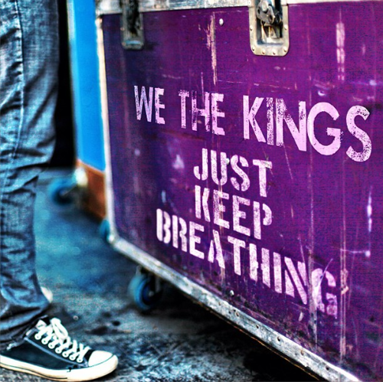

Say You Like Me
She's the girl that no one ever knows.
And I say hi, but she's too shy to say hello.
She's just waiting for that one to take her hand
And shake her up.
I bet I could.
I wish my heart was always on her mind.
'Cause she's on mine like all day, all the time.
Forget me not, forget me now.
I’ve come too far to turn around.
I’m here tonight.
'Cause I'm never going down,
I'm never giving up.
I'm never gonna leave,
So put your hands up.
If you like me,
Then say you like me.
I'm never going down,
I'm never giving up.
I'm never gonna leave,
So put your hands up.
If you like me,
Then say you like me.
Whoa, oh, oh, oh.
Whoa, oh, oh, oh.
Whoa, oh, oh, oh.
Whoa, oh, oh, oh.
She's the girl that no one ever knows.
Works a double just to buy her clothes.
Nicotine and faded dreams,
Baby, just believe
There's no one else like me.
'Cause I'm never going down,
I'm never giving up.
I'm never gonna leave,
So put your hands up.
If you like me,
Then say you like me.
I'm never going down,
I'm never giving up.
I'm never gonna leave,
So put your hands up.
If you like me,
Then say you like me.
Whoa, oh, oh, oh.
Whoa, oh, oh, oh.
Whoa, oh, oh, oh.
Whoa, oh, oh, oh.
It's time to fall into my arms.
'Cause I've been waiting for too long.
You're an angel,
Grab your halo,
And lets fly tonight.
'Cause I'm never going down,
I'm never giving up.
I'm never gonna leave,
So put your hands up.
If you like me,
Then say you like me.
'Cause I'm never going down,
I'm never giving up.
I'm never gonna leave,
So put your hands up.
If you like me,
Then say you like me.
I'm never going down,
I'm never giving up.
I'm never gonna leave,
So put your hands up.
If you like me,
Then say you like me.
Whoa, oh, oh, oh.
Whoa, oh, oh, oh.
Whoa, oh, oh, oh.
Whoa, oh, oh, oh.
Just say you like me.

