Lightspace Play Floor Comes to the Classroom

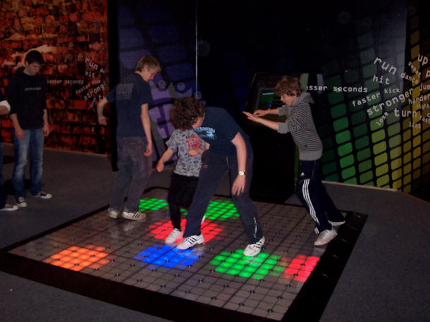
Andrew Huber

Adelphi University

Physical Education

Introduction | Tasks | Process | Evaluation | Conclusion/References

Introduction
If your looking for a recreational experience that will provide hours of entertainment for children and adults, than the Lightspace Floor is exactly what you’re looking for. The Lightspace is a great idea for all age groups to become more active without even realizing it. It is a revolutionary entertainment system that combines the latest display of technologies to produce something that everyone and anyone can enjoy.

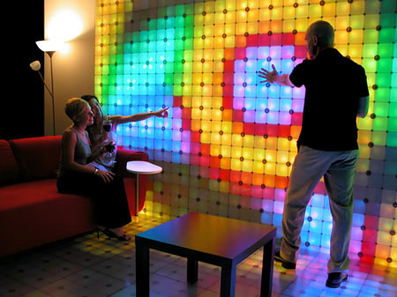

Task 1: Background Information- Get to know the Lightspace

Task 2: Skills needed and learned with the Lightspace

Task 3: How the Lightspace can be used in Physical Education

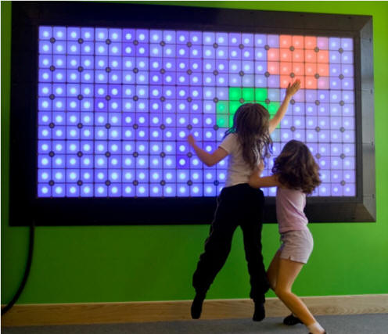

Process

- The Lightspace Play is a new device that will have a promising future. The system is capable of storing and running a myriad number of games and programs that can be played by any number of participants simultaneously. The Lightspace provides hours and hours of endless entertainment that will draw in young children, teenagers, and adults all the same. The Lightspace Play Floor is composed of an interactive floor surface comprised of 16”x 16” programmable LED lit and pressure sensitive tiles constructed to fit a 10 foot square space, each tile consisting of 16 4”x 4” pixels that can display any color, pattern, or image. The surface is able to detect moment, location, and density of players to give a more realistic experience for the gamer. The gamer gets a chance to use their hands, feet, and items such as balls to interact with the Lightspace Floor. The Lightspace is a great way to incorporate physical activity and electronic entertainment.

- There are many skills that one would need to play the Lightspace Play Floor. Agility is one skill that the participants of the Lightspace must have. There is an unlimited amount of movements and exercises that can be taken away from the Lightspace Floor. Whether being alone or with five of your friends on the floor your going to have to be agile to move around on the floor. The participant must have coordination. When different colors of lights and patterns are flashing on the floor and you need to step on them or perform any 1 of a handful of activities coordination is very important that you can move around the floor. One must have good balance to be able to perform different movements without falling off the floor or placing their leg down on a spot by accident. The Lightspace floor can require mostly any skill that any real sport or physical activity may require.

- The Lightspace Floor could very easily be incorporated in the physical education curriculum. The floor gives kids and very fun and involved way to participate in physical activity. It would make a great tool especially on the elementary level. The floor can perform a myriad number of activities and games that will test and teach children and adults alike physical skills such as balance, coordination, focus and agility to name a few. The interactive light up tiles and the bright flashy colors would attract any age group. It’s amazing on how much of a workout one or five people can get from being on the Lightspace floor at one time. The Lightspace floor provides an environment with little to no pressure to perform under pressure.
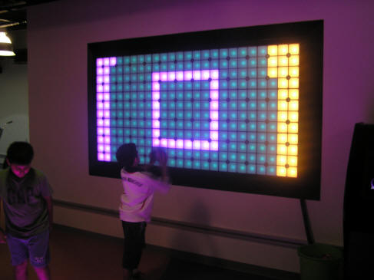

Evaluation/ASSESSMENT
Q&A
True or False: 1) Two people can play on the Lightspace Floor at a time?
2) The Lightspace Floor contains 10 fun filled games? If False how
many?
3) The Lightspace is a revolutionary, interactive and engaging way
for people of all ages to play, dance, design, get fit and above
all, have fun?
4) The Lightspace Floor contains games and activities that teach
and build a variety of physical skills?

 | Good | Better | Best
Task 1-Knowledge | Can answer 1 out of 4 questions | Can answer 2-3 out of 4 questions | Can answer 4 out of 4
Task 2- Actions | The participant/participants have very basic comprehension of the Lightspace Floor. | The participant/participants can somewhat comprehend and participate in the use of the Lightspace Floor and an intermediate level. | The participant/participants can comprehend and participate in the use of the Lightspace Floor even on the most difficult activities.
Task 3- Reflection/Connections | The participant uses the skills gained but seldom. | The participant uses the skills gained a few times a week. | The participant uses the skills gained on a daily basis.

Conclusion/References

http://www.exergamefitness.com/lightspaceplay.htm

http://www.lightspacecorp.com/products/

http://www.lightspacecorp.com/

http://www.bhmvending.com/Amusements/Lightspace/Lightspace.html

