NISSAN 350Z

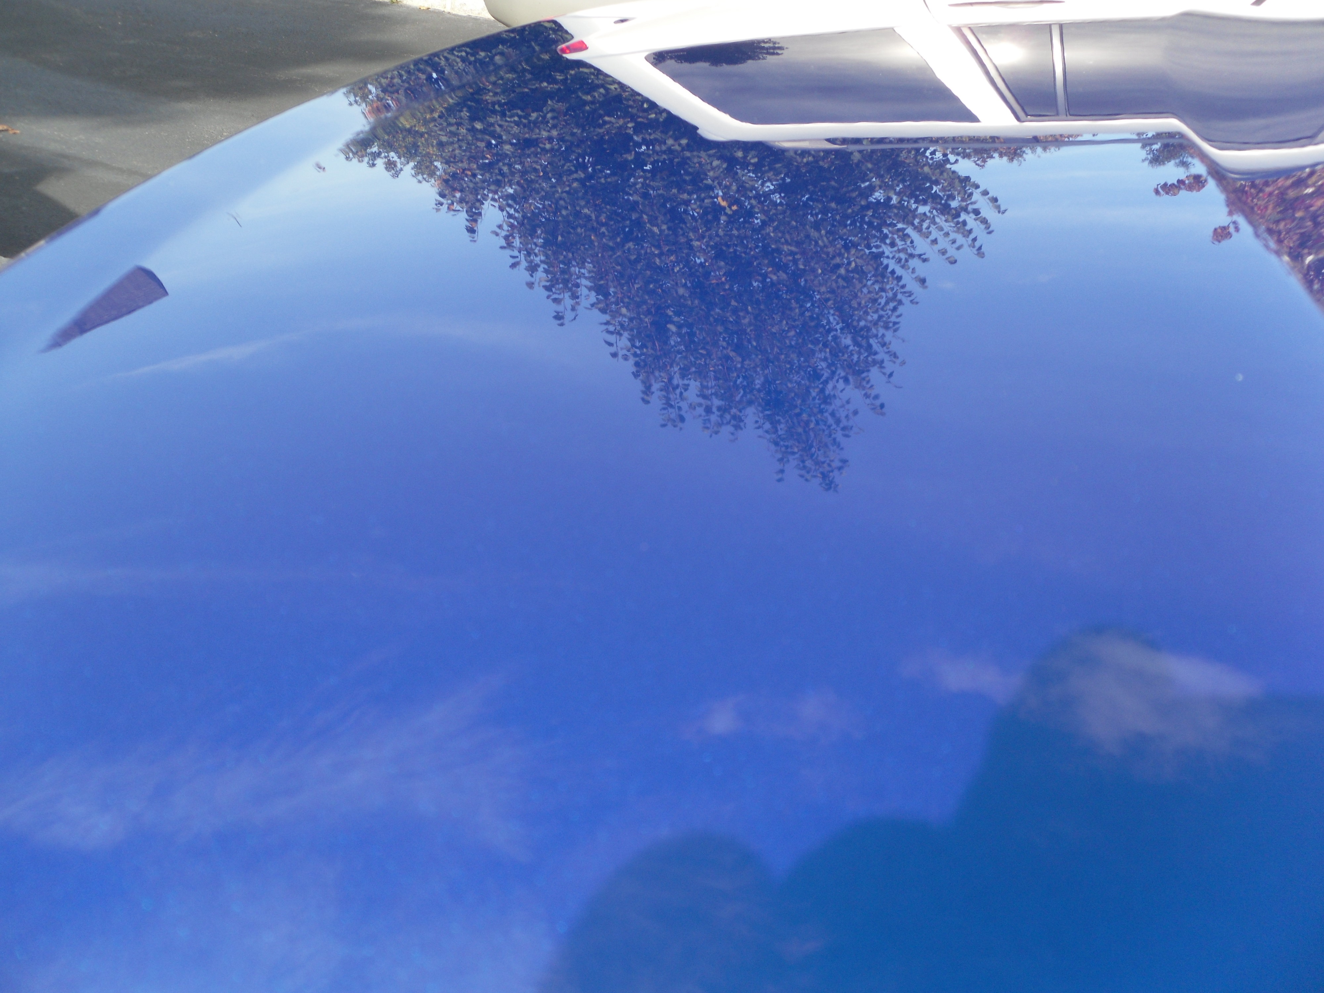
MY PAINT AFTER A WASH AND WAX

